Meta Title: TonyBet Sportsbook Review in Ontario
Meta Description: Check out my detailed review for TonyBet Ontario Sportsbook. Get a player-focused breakdown on the betting markets, odds, payment methods, security, and more.

TonyBet Ontario Sportsbook Review: My In-Depth Analysis
Affiliate disclosure: OntarioGamers.ca earns commission when you sign up through our links — at no extra cost to you. This, however, does not influence our editorial recommendations.

TonyBet Ontario Sportsbook: Quick Facts
Overall rating | 8.410
Operator’s legal name | TonyBet Ontario
Parent company | Ligtip Limited
AGCO registration | Active under license no. OPIG1239101
Launch date in Ontario | 2023
Minimum deposit | $10
Minimum withdrawal | $10
Sports covered | 25+ including football, basketball, ice hockey, and baseball
Betting markets | Prematch and live betting
Bet types | Singles, parlays, and other standard bet types
Early cash-out | Available
Same game parlays | Yes
Live streaming | No
Withdrawal time | 12 hours - 7 days
Mobile support | Yes; browser-friendly website, iOS & Android app
Age requirement | 19+
Play Now at TonyBet Ontario
19+ | Ontario Only | Play Responsibly

TonyBet Ontario Sportsbook at a Glance
Looking for a legal Ontario sportsbook with wide sports coverage, a user-friendly interface, fast 24-hour payouts, and competitive odds? TonyBet Ontario Sportsbook delivers all that and more, right from your desktop or mobile.
While the Latvia-based TonyBet Sportsbook launched in Ontario early 2023, its roots can be traced back to 2003 when it first launched as Omnibet. Professional poker player Tony G later acquired it in 2009 and rebranded it to TonyBet. Today, TonyBet is a fully independent company and is fully licensed by the Alcohol and Gaming Commission of Ontario (AGCO) and iGaming Ontario, giving local bettors access to legal and secure betting options.
More than two decades later, the site continues to stand out with its excellent coverage of esports and traditional sports, as well as its smooth betting experience on desktop and mobile. Not to mention the brand is the official sports betting and online casino partner of the Canadian Premier League as well as the official sports betting partner of the Canadian Elite Basketball League.
In this TonyBet Sportsbook Ontario review, we go through the site’s key features and where it exceeds expectations. And since this is an unbiased review, we also look at areas where this licensed Ontario sportsbook could improve.

TonyBet Ontario Sportsbook: Pros & Cons

Pros | Cons
- Over 25 sports to bet on | - No live streaming
- One of the deepest esports coverage | - Average odds
- Solid native apps | - Lacks phone support
- Strong live betting section with bet builder for same game parlays
- AI analytics tool for in-depth stats for each bet

How to Sign Up at TonyBet Ontario Sportsbook
During testing, it only took two minutes to set up my TonyBet Ontario account. The process was intuitive and mobile-friendly, with smooth transitions between fields and fast ID verifications. Keep in mind that you must verify your account before you can access the sportsbook in full.
Follow these quick steps to start playing:
- Click Sign Up: The orange Sign Up button sits prominently at the top right. Select it to begin.
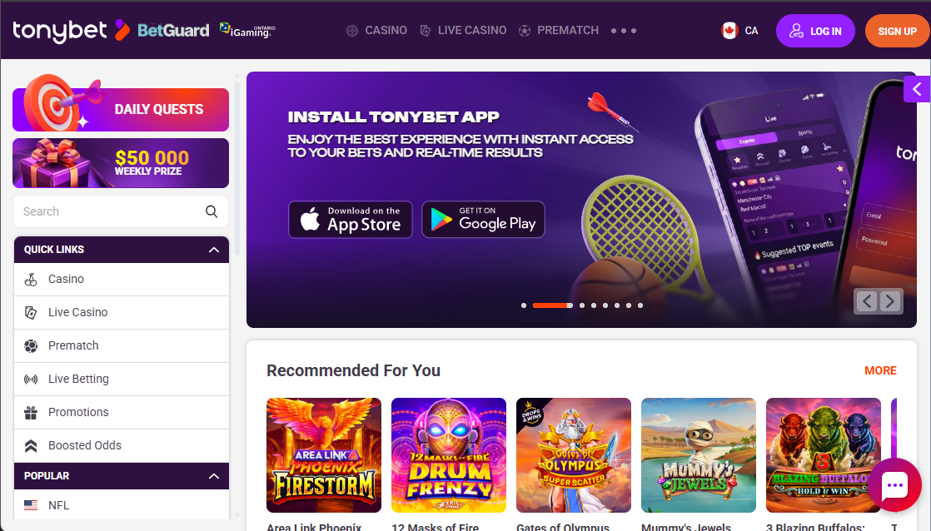
- Fill in your details: Enter your email, password, full name, occupation, phone number, date of birth, and gender. Hit ‘Continue to Step 2’ to proceed.

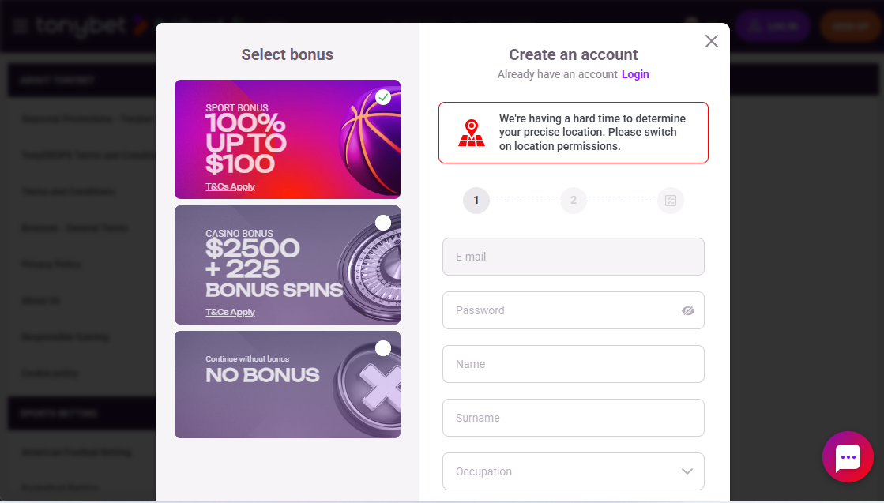
- Provide further information: You’ll be asked for your full residential address, which you can fill in manually or find it via Postcoder.
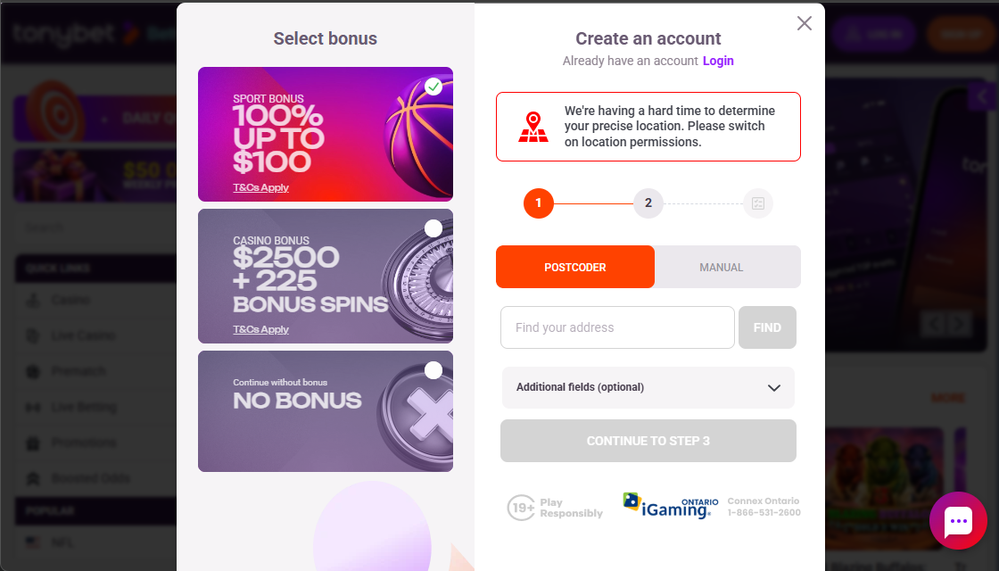
- Agree to the terms: Tick the relevant boxes to confirm you’re not a politically exposed person and that the data provided is accurate. Tap ‘Sign Up’ and you’re done.
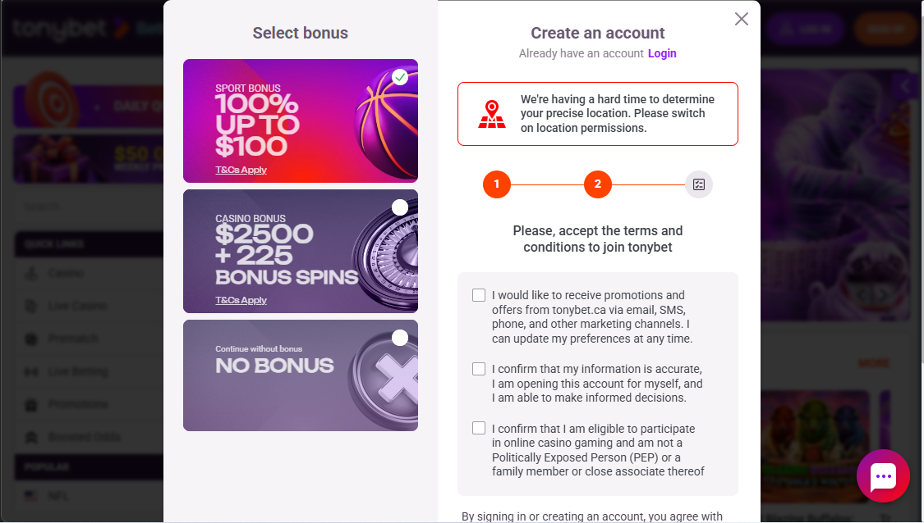
After completing all the steps above, TonyBet’s automated system will verify your location and account in under two minutes. However, if it flags a mismatch, you’ll need to complete a manual verification process, which can delay account access for up to 48 hours.

How Long Does Account Verification Take at TonyBet Ontario?
As required under the Ontario regulatory framework, TonyBet requires all new account holders to verify their identity before fully accessing your account and start betting. While testing, account verification was automatic. Soon after completing the registration steps, I was able to instantly complete my TonyBet Ontario login and deposit funds.
However, a manual review may be necessary if automatic verification fails. In this case, you’ll need to submit a copy of your identity card, driver’s license, or passport along with a recent utility bill or bank statement as proof of address. You may also need to submit a selfie holding your identification document.
Manual verification can take up to two days before you can fully access your TonyBet account.

Betting Options at TonyBet Ontario
After a fast sign-up, I landed on a clean, tabbed interface where it was easy to jump between Casino, Live Casino, Prematch, Live betting, Promotions, and Pick’Em. Clicking the ‘Prematch’ tab from the main menu at the top of the screen gave me access to the sports betting section.
Navigation was straightforward, with sub-menus like ‘Hot Combos’ and ‘Boosted Odds’ making exploration simple. You can also filter by competitor, league, tournament, or sport to narrow things down even more quickly.

What Sports Can You Bet on at TonyBet Ontario?
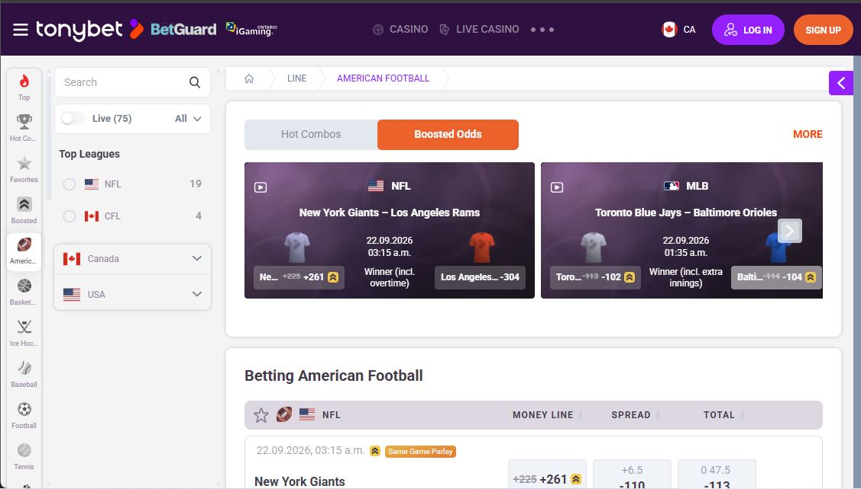
TonyBet Sportsbook is best known for its extensive coverage of both traditional sports and esports. Along the left-hand side of the homepage, I found a list of 25+ sports, including:
- Soccer
- Ice hockey
- Baseball
- Basketball
- Tennis
- Cricket
- Volleyball
- Snooker
- Rugby
- Futsal
- Boxing
- Formula 1
- Table tennis
- Waterpolo
- Darts
- Cycling
- Golf
- Alpine skiing
- Gaelic football
- Esports
Based on my assessment, TonyBet covers the full Canadian sporting calendar, from the CFL and Canadian Open to international competitions such as the NFL and NBA, so there’s always plenty to explore.
What stood out most during testing, however, was the esports coverage at TonyBet Ontario. While there are only a handful of options (Rainbow Six, League of Legends, DOTA, and Counter Strike), the depth of the markets available was impressive. Beyond the standard match-winner market, I also found total maps and map handicap, giving esports fans way more approaches to a match.

How Competitive are the Odds?
Odds can make a noticeable difference to the potential return, particularly for bettors who regularly compare prices across sportsbooks. During my testing, I checked TonyBet's CFL markets and found a decent selection of standard pre-match options with pretty average odds, although certain selections offered slightly better or lower returns .
I liked that each match presented several betting options, more than the standard outright markets. TonyBet also displayed the available prices clearly, making it easy to compare the moneyline, spread, and total before adding a selection to the bet slip.

Live Betting Experience
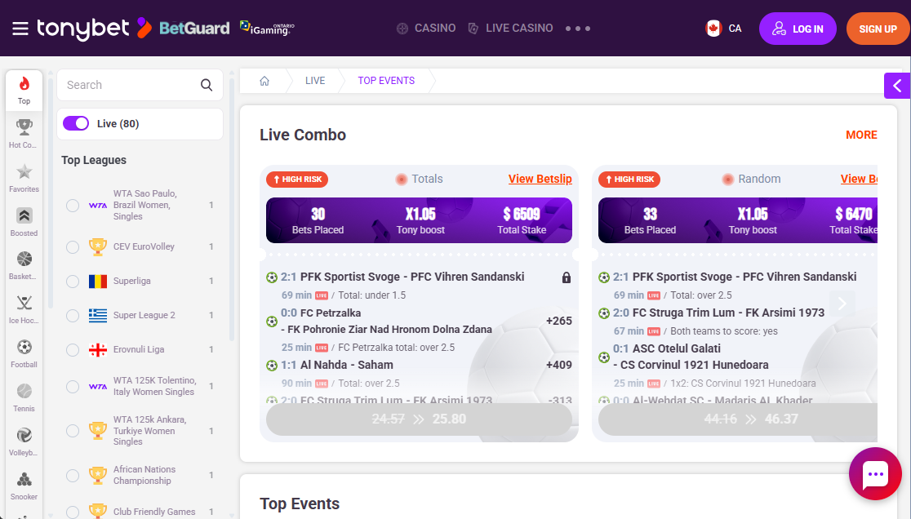
TonyBet Ontario delivers a robust in-play wagering section, with several deep markets and a helpful bet builder that lets you stack several legs from one match into a single bet slip. At the time of testing, I found live matches across soccer, tennis, volleyball, basketball, and ice hockey.
The odds updated fast as the action unfolded, although a few markets were temporarily suspended before the odds refreshed. The lack of live streaming functionality was a downside, but with key match information displayed alongside the available markets, I was able to keep up with the action. The overall experience made it relatively easy to find a particular live market and add a selection to the bet slip.

Cash Out: How Well Does It Work?
Early cash out is available on TonyBet Ontario Sportsbook, although it’s only accessible on straight bets and parlays across select games and matches. That means you can settle your bets early, either by taking out a portion of your winnings early or by cutting a portion of your losses with a partial refund before the event ends.
Worth noting, however, is that cash out isn’t necessarily the best-value option for every bet, as the amount offered may be lower than the potential return if the bet wins.

Mobile App and Website Experience
I tested TonyBet Ontario on both desktop and its iOS app and overall performance was fast and stable.

My TonyBet Sports Betting Experience on Desktop
Upon landing on the desktop site, everything was clearly laid out and easy to find. The different sections of the site, including Casino, Live Casino, Pre-match, Live betting, Promotions, and Pick’em, are at the top menu on the main page. Whether you choose pre-match or live betting, both take you to a list of popular events. If you want to browse per sport, they are all available on the left side of the homepage.
One thing that might feel a bit much, especially for new bettors, is how the odds are displayed. When there are many in-play or pre-match events, the layout can feel somewhat cluttered. However, experienced bettors may appreciate having multiple markets and odds visible in one place.
Despite this, I found navigating the desktop site smooth and responsive. Depositing, switching between events, placing a bet, and requesting a cash out were all straightforward during my testing.

My TonyBet Sports Betting Experience on Mobile
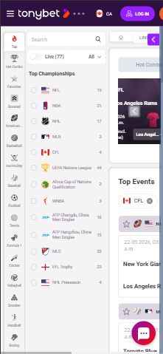
TonyBet Ontario offers a browser-friendly site along with dedicated apps for iOS and Android devices. I tested the mobile site and the app on an iPhone 16, and navigation was generally smooth.
The looks and general feels of the TonyBet app mirror the desktop site as with most licensed Ontario sportsbooks. I liked that every betting market available on desktop was also accessible on mobile. However, I preferred using the app and mobile site in landscape mode, just so that everything, from event display, bet slip, in-play betting section, and My Account, could fit on the screen without endless scrolling.
Pages and betting markets loaded quickly during my testing, and I didn't experience any crashes or stability issues. The login process was also straightforward, allowing me to access my account without unnecessary steps.

Key Reasons to Join TonyBet Sportsbook
- Wide range of betting markets: Access popular sports alongside more specialised markets and player props.
- Strong live betting selection: Find in-play markets across sports including soccer, tennis, basketball, volleyball, and ice hockey.
- Easy-to-use bet slip: Add selections, adjust your stake, and review potential returns from one place.
- Mobile-friendly experience: The mobile site and dedicated apps provide access to the same core betting markets as the desktop version.
- Bet builder: Combine multiple selections from the same match into one bet across select matches and events.
- Cash-out functionality: Eligible straight bets and parlays can be cashed out before an event ends.

Deposits and Withdrawals
TonyBet Ontario keeps its banking options fairly simple, with four payment methods available: Visa, Mastercard, Interac e-Transfer, and MuchBetter. There are no additional fees for deposits or withdrawals.

Deposits
Although only a handful of banking options are available on TonyBet Ontario, the list covered a lot of bases. The minimum deposit is also fair at $10 across all available methods. However, I found that a $20 deposit was required to activate a payment method on the account.
I tested an Interac e-Transfer deposit. The process was straightforward, and the funds appeared in my TonyBet balance instantly.

Withdrawals
TonyBet supports withdrawals through the same payment methods available for deposits, with a $10 minimum withdrawal.
I used Interac for my first withdrawal because it was also the method I used to deposit. Before the withdrawal could be processed, TonyBet asked me to provide additional verification documents. My account was approved roughly four hours after submitting the requested documents.

Customer Support: I Put It to the Test
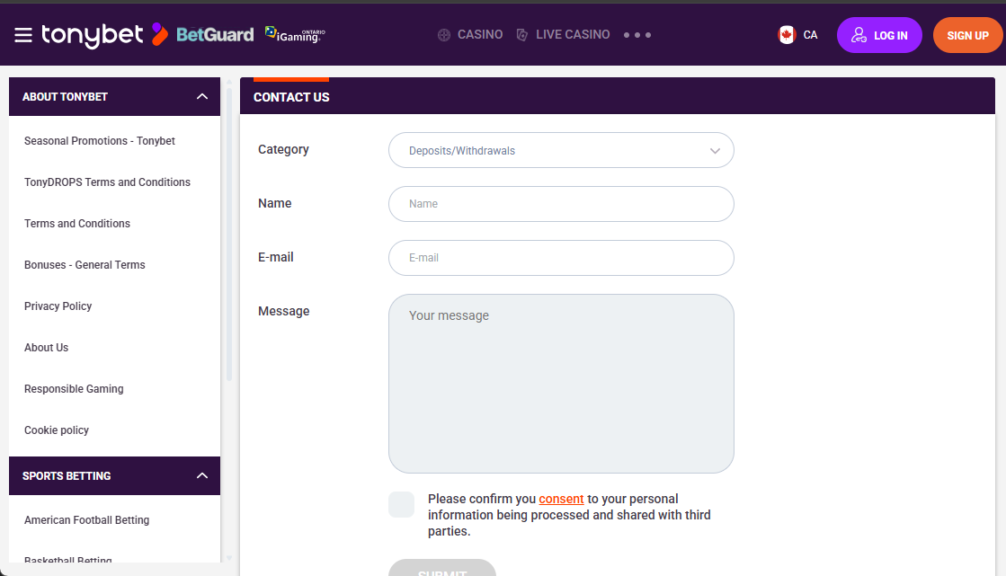
TonyBet Ontario provides 24/7 customer support through live chat and email. There is no phone support, but the website has a detailed FAQ section covering topics such as betting, payments, accounts, and cash outs.
I tested the live chat with a question about my withdrawal request. A support agent joined the conversation almost immediately, which was useful when I needed a quick response. However, some of the answers were fairly vague and didn't fully address my questions, and I noticed a few grammatical errors.
I also contacted support by email through the website's contact form. TonyBet states that email queries can take up to 24 hours to receive a response. In my case, I received a reply within 18 hours.
All in all, live chat is the faster option when you need immediate assistance, but the quality of the answers may depend on the question. Email support took longer but responded within the stated timeframe.

Responsible Gambling Tools
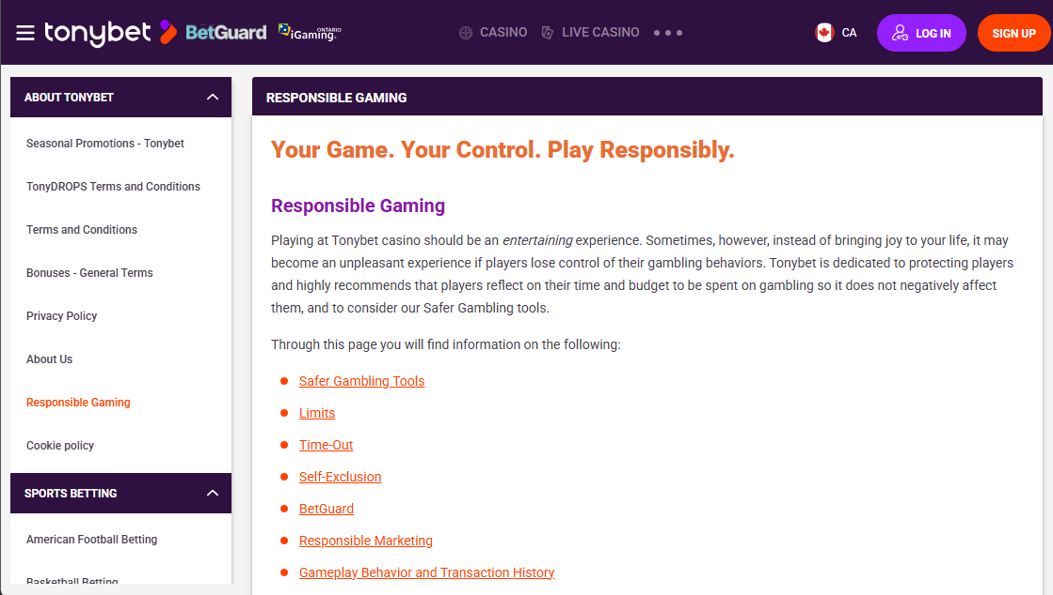
TonyBet Ontario provides several responsible gambling tools that can be accessed through the account settings. During my testing, I found options for:
- Deposit limits
- Loss limits
- Session reminders
- Time-out periods
- Self-exclusion
The platform also provides self-assessment tools and links to organisations such as ConnexOntario and the Responsible Gambling Council.
The main question for me was how easy these controls were to find. I was able to access the main responsible gambling options through the account settings without having to search through several different sections.
TonyBet covers the core tools expected from a regulated Ontario sportsbook, although I didn't find anything that appeared to go substantially beyond the standard responsible gambling features available in the market.

Final Verdict
TonyBet Ontario provides a straightforward sportsbook experience across desktop and mobile. I found the main betting markets easy to navigate, while the live betting section offered a good selection of sports and markets. The mobile experience was also smooth, with the core betting functionality available through the app and mobile site.
The main drawbacks I noticed were the somewhat busy odds layout when many events were displayed, limited payment options, and some more specialised markets requiring additional taps to find. Customer support was quick to respond through live chat, although some answers lacked detail.
Overall, TonyBet Ontario Sportsbook is best suited to bettors looking for a straightforward platform with a broad selection of pre-match, esports, and live betting markets. However, it may be less suitable for players who want more payment options or an easier way to browse specialised markets.

TonyBet Ontario Sportsbook FAQs

Is TonyBet legal in Ontario?
Yes. TonyBet operates in Ontario's regulated iGaming market and is licensed by the Alcohol and Gaming Commission of Ontario (AGCO).

Is TonyBet a legitimate sportsbook?
Yes. TonyBet operates as a regulated sportsbook in Ontario and provides standard security, account verification, and responsible gambling measures.

Can I use the same TonyBet account for casino and sports betting?
Yes. TonyBet combines its casino and sportsbook under one account, allowing you to use the same login and account balance for both products.

What payment methods can I use with TonyBet Ontario?
TonyBet Ontario supports Visa, Mastercard, Interac e-Transfer, and MuchBetter for deposits. The available withdrawal options are the same.

How long do TonyBet withdrawals take?
Withdrawal times depend on the payment method and any verification required. During my testing, my first Interac withdrawal arrived in less than 12 hours after my account was approved. Visa and Mastercard withdrawals can take up to 24 hours.

Can I use TonyBet Ontario on mobile?
Yes. TonyBet Ontario offers dedicated iOS and Android apps as well as a mobile-friendly website. During my testing on an iPhone 16, I found the mobile experience smooth, with the main betting markets and features accessible from the smaller screen.
Please play responsibly. If you need support, contact ConnexOntario at 1-866-531-2600.
